The World’s Four Best Rock Climbing Destinations
Rock Climbing can be a very challenging and fruitful sport. The true beauty of rock climbing is that you get to travel. You get to see new places, view new sights, and at the same time, have the sensation of purpose, set out and do something, reach a certain point. It is both relaxing and straining at the same time. It is one of the most healthy and physically and mentally healing activities that you can do if you are up to it. We looked into the best rock climbing locations across the globe and came up with give four top ones.
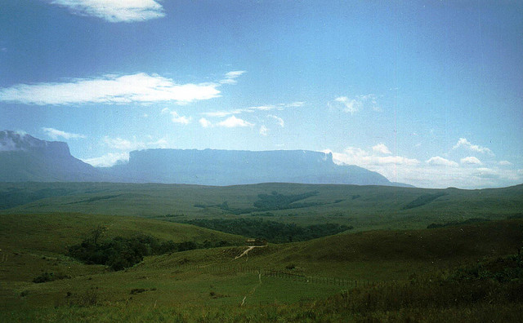
http://www.flickr.com/photos/svalkenberg/4138966143/

Mt. Roriama, Venezuela
The mountain is at the border of Brazil, Venezuela and Guyana. The location covers over thirty thousand square kilometres of land area, and offers some of the most beautiful sceneries to be seen on the face of the earth. The mountain has the world’s highest mountain plateau, at almost three thousand meters in height. The whole area comprises of land that is said to have sustained for two billion years on the earth’s crust. Apart from the mountains, there are numerous lakes, waterfalls, plants and animals and other instances of nature that you are sure to meet while you climb. However, the only thing to keep in mind is that climbing Roriama is no child’s play and that you need to be specially equipped to be able to do it right.
Death Valley, Arizona
This amazing landform, perfect for rock climbing and safe enough for novices, is located in the Colorado plateau. It is a vast place covering eighty five thousand acres of land. The particular climbing place that we had in mind is the Spider Rock. This landmass has an overall alluring red stone outlook and comprises of two towers as high has eight hundreds stone steps. Do keep in mind that natives of the area worship the rocks, and that the land is a government protected site where no nuisance can be tolerated.
Cuerno Del Paine
Imagine a three thousand foot high structure of rocks made out of pink granite overlooking greenish blue lakes, pampas, fjords and rivers. It’ll seem like you’re in another planet, wouldn’t it. Such is the beauty of the Cuerno Del Paine rocks in Chile. The rock climbing structures are endless and there are numerous opportunities to be taken advantage of. If you are trained in the art of climbing rocks, these structures will both bowl you over with their beauty as well as strain you physically and emotionally with their sheer heights.
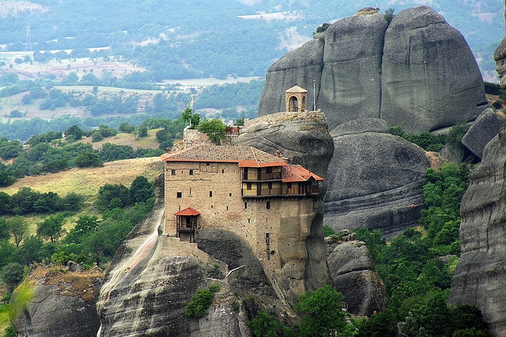
http://www.flickr.com/photos/lorenzodellaragione/9679286241/
Greece, Meteora
Almost every tourist magazine’s rendition of Greece covers the Meteora rocks in their skyline. They are the single most beautiful aspect of nature that sets the country apart. They are not too high, at three hundred metres, but it would still be worth it as the massive black rocks that hang down giving the place an unreal feeling. The cliff of the mountain offers amazing views and make for the sheer pleasure of having climbed the whole distance.

